**PRAKTIKUM PEMROGRAMAN BERBASIS WEB (A)**



Oleh :

Muhammad Rachel Fathan Idzhany

4522210071

**Dosen:**

**Adi Wahyu Pribadi, M.Kom.**

**S1 – Teknik Informatika**

**Fakultas Teknik Universitas Pancasila**

**2024/2025**

Program:  
  
/config/Database.php

/Controllers/AdminController.php

/controller/GuestController.php

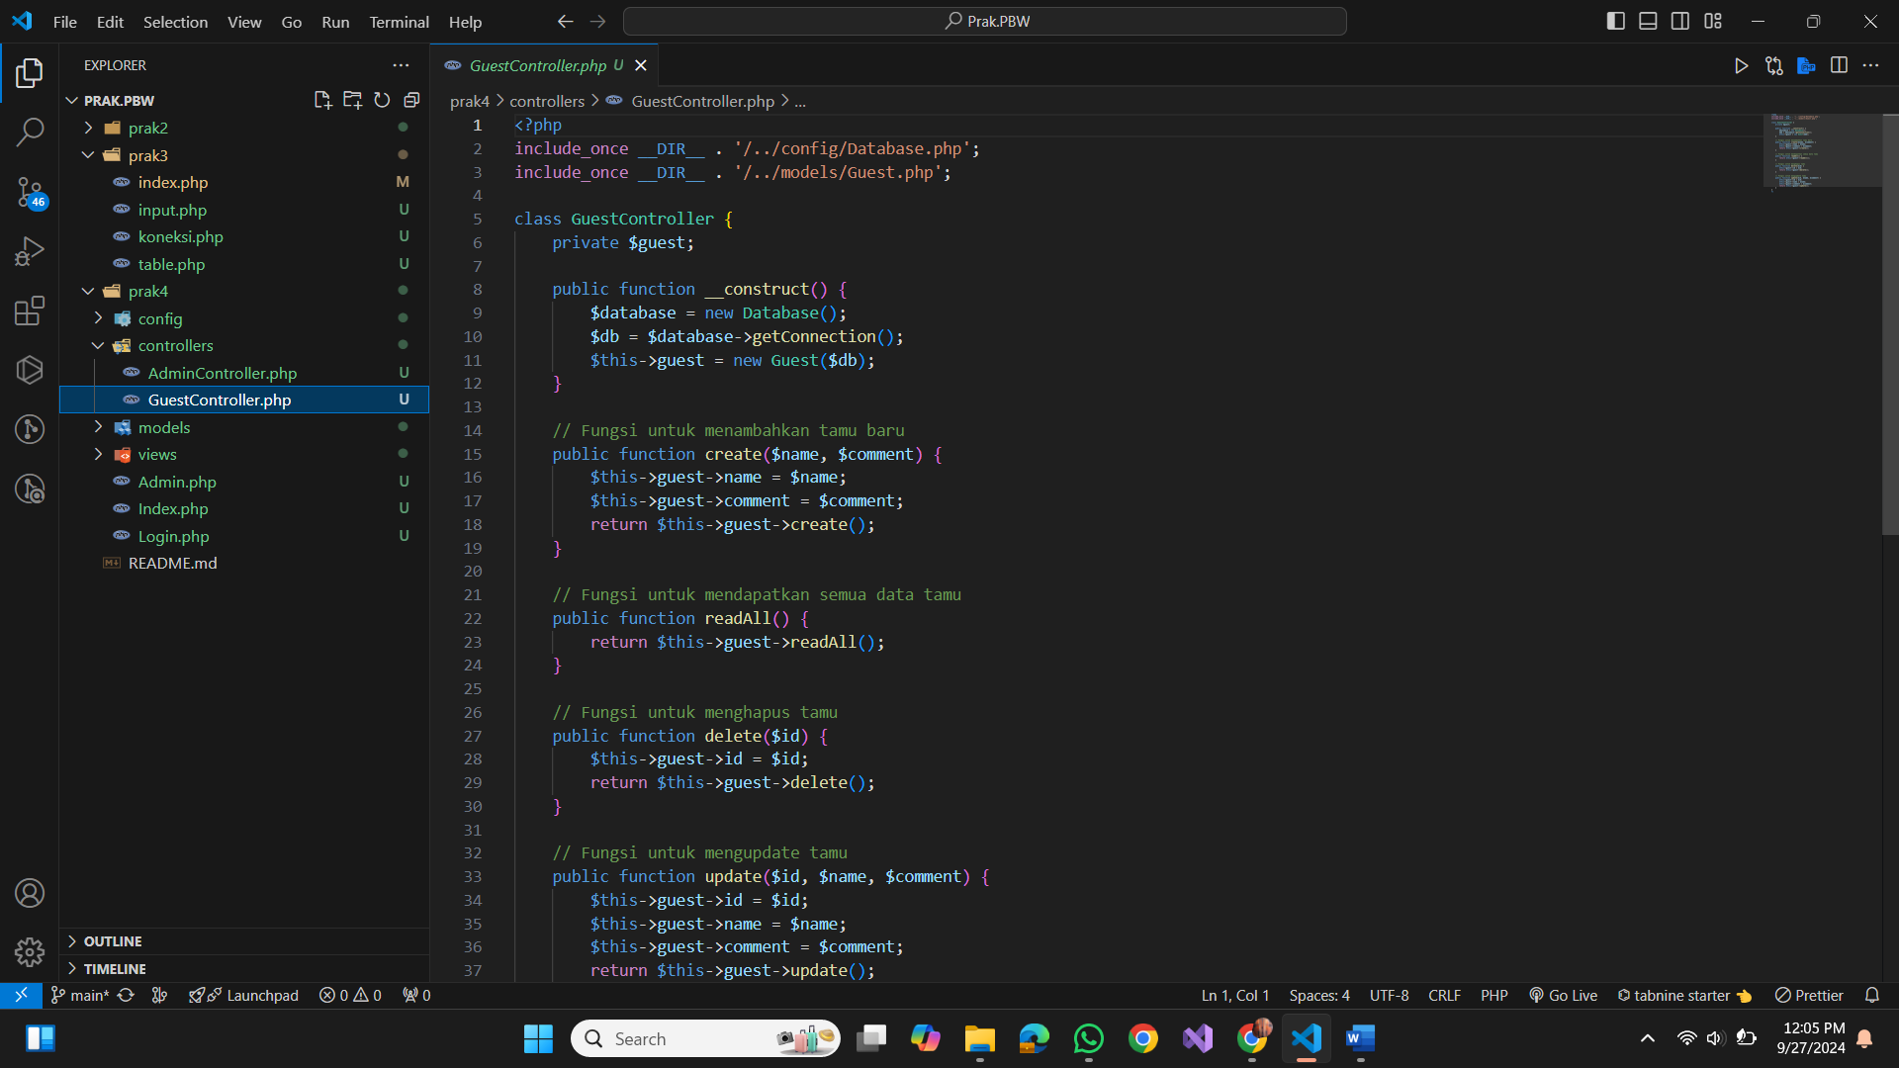

/models/Admin.php

/Admin/Guest.php

/views/ admin_dashboard.php

/views/admin_login.php

/views/Edit.php

/views/guest_form.php

/views/guest_list.php

/views/logout.php

Admin.php

Index.php

Login.php

Database:

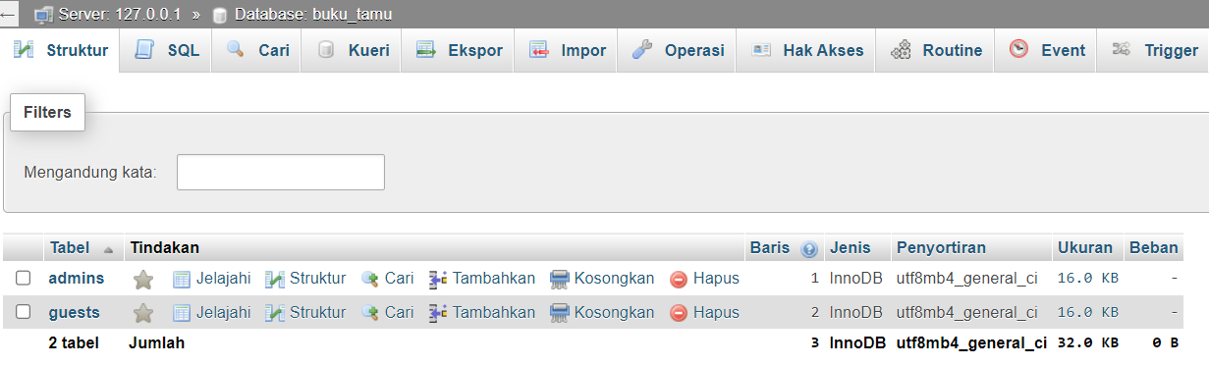

Hasil Run:

